Re cap from last meeting
Task:
- Consult Bruce re Abnormal security. (completed)
- Review with Bruce an Joel re USB auditing and controls. (Completed)
- One month audit on Mass media usage. (Complete)
- Find the Acceptable use Policy re computer use and removable media (completed)
- Review factory for devices that could receive a USB
- Consult with Joel re Simulation. (Completed)
- Discuss with Ali re toolbox

Progress
- As noted in the emails that have been shared the system of USB monitoring and management is Sophos
- Information provided by Sophos is limited to: Time/Date, Device, User, Machine and machine IP. This does not highlight use cases however I will attempt to contact the users and ascertain a range of use cases.
- Sophos monitors most but not all devices in the network. Analysis of the unprotected devices and their business impact may be required.
- Sophos also has a large scope for removable devices, data pertaining to removable devices that were not data carriers was removed from the data set.
- Sophos includes mobile phones as removeable media due to the capacity to move data, I agree with this logically but have isolated the data pertaining to mobiles from data pertaining to USB devices
- For the previous 30 days as of 7/2 1680 instances of phones being plugged into devices with data migration capacity was detected, and 366 instances of USB media with data migration capacity were utilised in managed devices.

Simulation
- Proposed simulation is lolly jar of USBs in various locations, with a method of tracking who plugs them in.
- Initial idea is to have a program loaded on them that would report when plugged in like an OMG cable or Rubber ducky like device.
- Problem 1, soft loaded onto the USB will not auto play as auto play was disabled in windows 8 and above to prevent that very thing, whilst it is possible to turn it on this would be opening up a security vulnerability for the sake of a test, not advised.
- Problem 2, professional devices use microcontrollers or modified boot drivers to stealthily gain ingress and control. Most commonly a USB that the pc believes is also a keyboard unknown to the use. These types of devises are expensive to buy on mass, and making them can be timely.
- Solution, 1 Sophos logs the manufacturing name of the device that is used, if we used a large number of the same USB that Sophos can uniquely identify, this would return the data we require.
Policy.
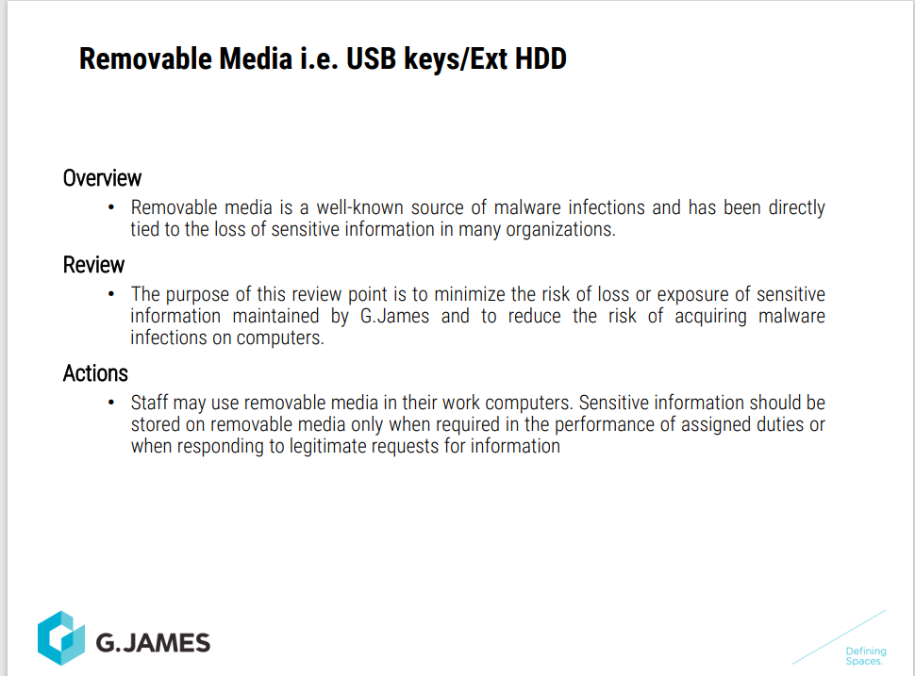

- I was able to find two documents re acceptable use of computer equipment.
- One document is rather thorough and well written but is still in draft state and has not been ratified by business or disseminated.
- The Orientation pack mentions briefly:

Current posture
- Acceptance of risk.
- Allow all devices.
- Not actively managed.

Risk
- Data exfiltration
- Malware past perimeter security.
Abnormal
- Had discussion with Bruce. He believes we may be able to add exemptions to Abnormal to allow the continuation of the simulation training. Further research required.

Tool box talk

